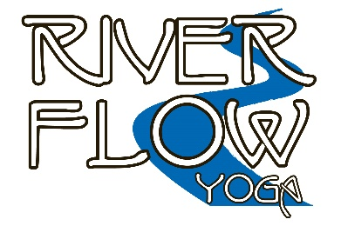
River Flow Yoga Teacher Training School
Application for 240 hour River Flow Yoga Teacher Training
Wausau, WI

How to Submit Your Application: Please fill out this form and save a completed copy. E-mail the completed application to Mary Hilliker at mary@riverflowyoga.net.

Applications can be made at any time. Early application is highly recommended.

Personal Information
Name
Mailing Address City State Zip Code
Country
Web site (optional):
Email address that you check regularly:
Home Phone: Mobile Phone:

The following information will help us to get to know you and guide your training.

Your Educational Background: Include Institutions, Degrees, and Attendance/Graduation Years.

Professional Background and Current Employment (position, focus of your work):

Are you interested in incorporating yoga teaching and yoga techniques into your current professional work? Yes No.

If yes, please let us know more about how you would like to incorporate yoga into your existing work.

Yoga Practice and Teaching Experience
When did you start practicing Yoga? What type of classes do you take? Do you have a home practice?

Have you participated in yoga classes, events or workshops with River Flow Yoga or 5 Koshas Yoga & Wellness? ___Yes ___ No
If Yes, please provide more information about what you’ve participated in.

Yoga Educational Background for Yoga Teachers
Please fill out any of the following sections that are applicable to your yoga educational background and experience.

Yoga Teacher Training Program (s) Information
School/Program Name | Dates Attended | # of Hours | Yoga Alliance Registered
 |  |  | Yes No
 |  |  | Yes No

If you are a yoga teacher, how long have you been teaching Yoga? What type(s) of classes do you teach? Do you work with students on a one-to-one basis?

Interest and Goals

What are your goals for this professional training?

How do you see your yoga career unfolding?

Please provide any additional Information about you or your background, other professional credentials and experience, academic background, life experience, and accomplishments that you would like to share. We look forward to getting to know you well!

Questions: Contact Mary Hilliker at mary@riverflowyoga.net or call 715.218.7120

Student Agreements

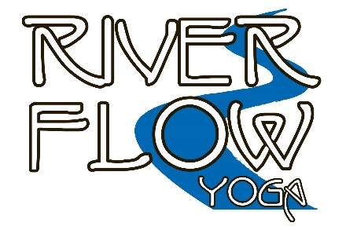
240 hour River Flow Yoga Teacher Training

Copyright Acknowledgement

I acknowledge that all student materials provided in this training, including print and audio, are the copyright of River Flow Yoga Teacher Training and are provided FOR MY PERSONAL USE ONLY. I acknowledge that I cannot alter or distribute in any way without written permission from Mary Hilliker or the respective guest faculty and the River Flow Yoga Teacher Training School.
Photo-Video-Audio Guidelines and Release
Staff may take photographs, video and record audio for use in future trainings or marketing of training programs. If you do not wish to be photographed or filmed, please advise the lead instructor. Students are permitted to take photographs as long as it is not distracting to the class. A student should ask classmates if they have their permission to be in personal photographs, especially if those photographs will be used on social media sites.
Recordings are not permitted without permission from the lead instructor.
I consent to being photographed and recorded, and grant River Flow Yoga, LLC and 5 Koshas Yoga & Wellness, LLC, its assignees, employees, and agents, the unrestricted and absolute right to use the photographs or recordings by any means now known or to become known. I hereby release & discharge River Flow Yoga, LLC and 5 Koshas Yoga & Wellness, LLC, its assignees, employees, and agents any & all claims of action, including, without limitation, libel, defamation, invasion of privacy or right of publicity, infringement of copyright, trademark or violation of any other right.
Yoga Teacher-in-Training Code of Ethics
A code of conduct is a declaration of acceptable ethical and professional behavior by which all yoga teachers-in-training agree to conduct themselves in the classroom, in teaching and in the business of yoga. We will foster an atmosphere of respect for each other and a learning environment conducive to the development of each student. As a River Flow Yoga Teacher-in-Training, I agree to uphold the following ethical principles:

- Conduct myself in a professional and conscientious manner in the training and in my teaching
- Refrain from the use of substances that impair my learning or judgment and associations while in the classroom
- Listen to and respect the other students in the training
- Acknowledge the limitations of my skills and scope of practice and where appropriate, refer students to seek alternative instruction, advice, treatment or direction
- Create and maintain a safe, clean and comfortable environment for the practice of yoga
- Make only realistic statements regarding the benefits of yoga
- Accurately reflect my yoga teaching credentials, qualifications, abilities, certifications and registrations
- Respect all copyrights and trademarks associated with the training
- Encourage diversity by respecting all students regardless of age, physical limitations, race, creed, gender, ethnicity, religion or sexual orientation.
- Respect the rights, dignity and privacy of all students in the training
- Avoid words and actions that constitute sexual harassment
- Avoid words or gossip or actions that may harm another student
- Adhere to the traditional yoga principles as written in the yamas and niyamas in my relationships with the other students in the training, the instructors, in my teaching and in my yoga business relationships
- Follow all local government and national laws that pertain to my yoga teaching and business

Adapted from the Yoga Alliance Code of Conduct.

Catalog Release
I have read and agree to the terms and conditions of application, admission, participation in and completion of the 240 hour River Flow Yoga Teacher Training.
Liability Waiver
I understand that yoga includes physical movements as well as an opportunity for relaxation, stress re-education and relief of muscular tension. As is the case with any physical activity, the risk of injury, even serious or disabling, is always present and cannot be entirely eliminated. If I experience any pain or discomfort, I will listen to my body, adjust the posture and ask for support from the teacher. I will continue to breathe smoothly.
Yoga is not a substitute for medical attention, examination, diagnosis or treatment. Yoga is not recommended and is not safe under certain medical conditions. I affirm that I alone am responsible to decide whether to practice yoga. I hereby agree to irrevocably release and waive any claims that I have now or hereafter may have against Mary Hilliker of River Flow Yoga, LLC and the business and staff of 5 Koshas Yoga & Wellness, LLC.
I agree to the following:
- Copyright Acknowledgement
- Photo-Video-Audio Guidelines and Release
- Yoga Teacher-in-Training Code of Ethics
- Catalog Release
- Liability Waiver
Print Name: ____________________________________________
Signature: _____________________________________________
Date: __________________________________________________

